Virtual Data Analyst Internship
Week 3 Report
Statistical Analysis and Predictive Modeling using R
Dataset: Titanic Dataset (Public Dataset)

1. Objective
The objective of Week 3 is to perform statistical analysis and develop a predictive classification model using R. The analysis examines relationships among important variables, conducts hypothesis testing, and develops a logistic regression model to predict passenger survival. Model performance is evaluated using a train-test split, classification metrics, ROC analysis, and diagnostic techniques.

2. Dataset Identification
The Titanic dataset was selected because it contains a binary outcome variable, Survived, together with demographic, passenger-class, and numerical variables suitable for statistical analysis and classification modeling.
Attribute | Details
Dataset | Titanic
Records | 891
Target variable | Survived
Prediction type | Binary classification
Categorical predictors | Pclass, Sex, Embarked
Numerical predictors | Age, SibSp, Parch, Fare
Model | Logistic Regression

3. Data Preparation
The dataset was inspected using str(), summary(), and missing-value checks. Missing Age values were handled using the median age, while missing Embarked values were handled using the most frequent category. Categorical variables required for analysis and modeling were converted to factors.
data$Age[is.na(data$Age)] <- median(data$Age, na.rm = TRUE)
data$Embarked[data$Embarked == ""] <- NA
modeEmbarked <- names(sort(table(data$Embarked), decreasing = TRUE))[1]
data$Embarked[is.na(data$Embarked)] <- modeEmbarked
data$Survived <- as.factor(data$Survived)
data$Pclass <- as.factor(data$Pclass)
data$Sex <- as.factor(data$Sex)
data$Embarked <- as.factor(data$Embarked)

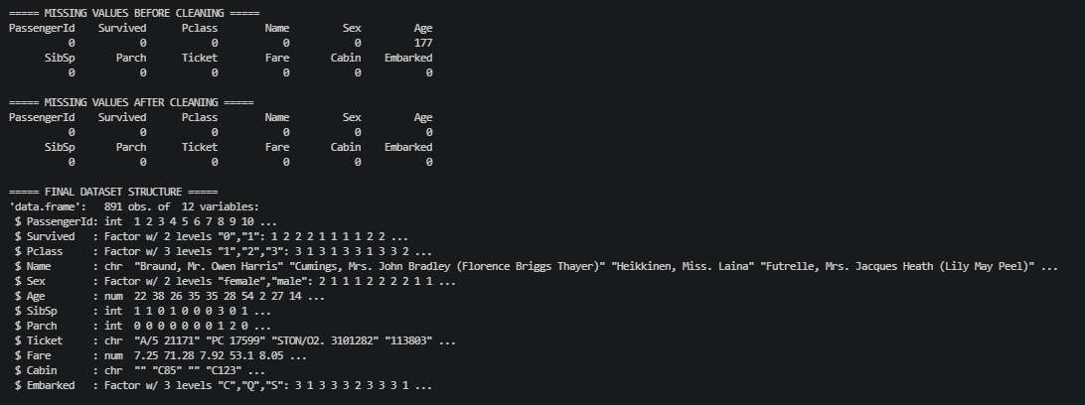
Data Structure & Cleaning Output:

4. Exploratory Statistical Analysis

4.1 Descriptive Statistics
Mean, median, and standard deviation were calculated for Age and Fare. Frequency tables were generated for survival status, passenger class, and sex.

4.1 Descriptive Statistics Output:
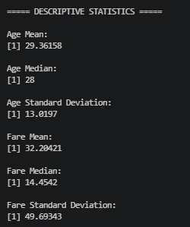

4.2 Correlation Analysis
Correlation analysis was performed for Age, SibSp, Parch, and Fare to examine the strength and direction of linear relationships among numerical variables.

Program Code:
numeric_data <- data[c("Age", "SibSp", "Parch", "Fare")]
correlation_matrix <- cor(numeric_data, use = "complete.obs")
print(correlation_matrix)

Correlation Analysis Output
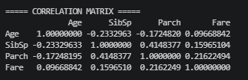

The correlations are generally weak to moderate, indicating that the numerical variables do not exhibit strong linear relationships with one another

5. Hypothesis Testing

5.1 Chi-Square Test of Independence
A Chi-square test was performed to examine whether passenger class and survival status were statistically independent.
H₀: Passenger class and survival status are independent.
H₁: Passenger class and survival status are associated.
survival_class_table <- table(data$Pclass, data$Survived)
chi_test <- chisq.test(survival_class_table)
print(chi_test)
Observed result: X-squared = 102.89, df = 2, p-value < 2.2e-16.
Because the p-value is below the 0.05 significance level, the null hypothesis is rejected. The result provides strong statistical evidence of an association between passenger class and survival status.

Chi-Square Test Output:
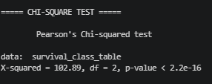

6. Logistic Regression Model

6.1 Model Development
A logistic regression model was selected because Survived represents a binary outcome. Passenger class, sex, age, and fare were used as predictors.

Program Code:
logistic_model <- glm(
Survived ~ Pclass + Sex + Age + Fare,
data = data,
family = binomial
)
summary(logistic_model)
The fitted model indicates that passenger class, sex, and age contribute significantly to survival prediction, while Fare does not show a statistically significant contribution at the 5% level in this model.

Logistic Regression Summary Output
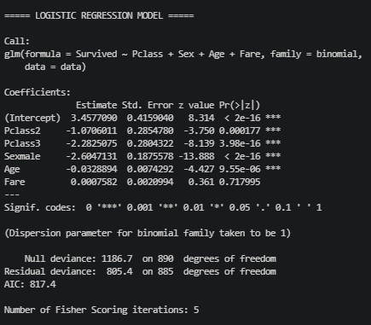

7. Train-Test Split
The dataset was divided into training and testing subsets using an 80:20 split. The training dataset contains 714 observations and the testing dataset contains 177 observations.
set.seed(123)
train_index <- createDataPartition(data$Survived, p = 0.80, list = FALSE)
train_data <- data[train_index, ]
test_data <- data[-train_index, ]
nrow(train_data)
nrow(test_data)

Train-Test Split Output:
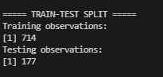

7.1 Cross-Validation:
To provide a more robust estimate of model performance, 5-fold cross-validation was used on the training dataset. The training data were divided into five subsets, with each subset used once as validation data while the remaining subsets were used for training. This process helps reduce dependence on a single train-test partition and provides a more reliable estimate of classification performance.

Cross-Validation Output:
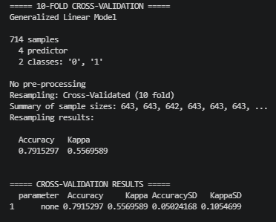

8. Model Training and Prediction
The logistic regression model was trained on the training dataset and used to generate survival probabilities and predicted classes for the test dataset.

Program Code:
train_model <- glm(
Survived ~ Pclass + Sex + Age + Fare,
data = train_data,
family = binomial
)
summary(train_model)
predicted_prob <- predict(train_model, newdata = test_data, type = "response")
predicted_class <- ifelse(predicted_prob >= 0.5, "1", "0")
predicted_class <- factor(predicted_class, levels = levels(test_data$Survived))

Trained Model Summary Output:
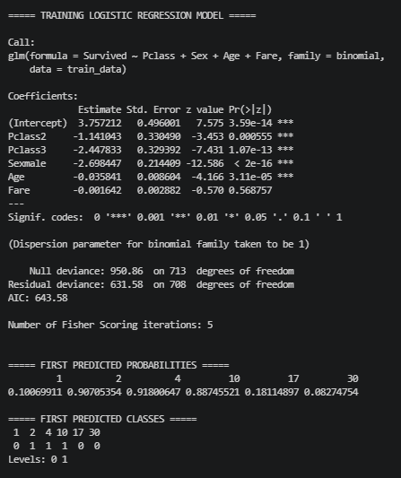

9. Model Performance Evaluation

9.1 Confusion Matrix
A confusion matrix compares predicted survival classes with actual classes in the test dataset. Accuracy, sensitivity, and specificity should be reported from the actual R output.

Program Code:
confusion_matrix <- confusionMatrix(
predicted_class, test_data$Survived, positive = "1"
)
print(confusion_matrix)
confusion_matrix$overall["Accuracy"]
confusion_matrix$byClass["Sensitivity"]
confusion_matrix$byClass["Specificity"]

Confusion Matrix of Modal Matrix:
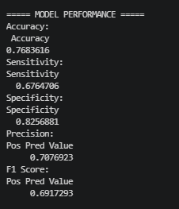
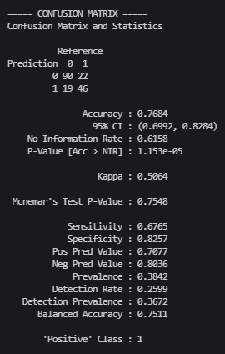

9.2 ROC Curve and AUC
The ROC curve evaluates the model's ability to distinguish between surviving and non-surviving passengers across classification thresholds. AUC provides a summary measure of discrimination.
roc_curve <- roc(
test_data$Survived, predicted_prob,
levels = c("0", "1"), direction = "<"
)
auc_value <- auc(roc_curve)
print(auc_value)
plot(roc_curve, main = "ROC Curve - Logistic Regression")

ROC Curve and AUC Output:
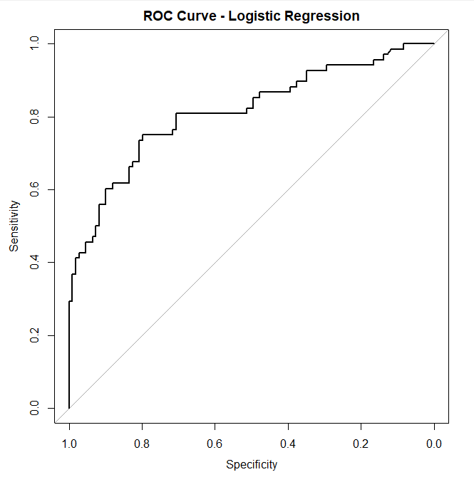

10. Diagnostic Analysis

10.1 Cook's Distance
Cook's Distance was used to identify observations that may have a relatively strong influence on the fitted logistic regression model. Most observations have small Cook's Distance values, while a small number show comparatively higher values and may warrant further investigation.

Cook's Distance Output:
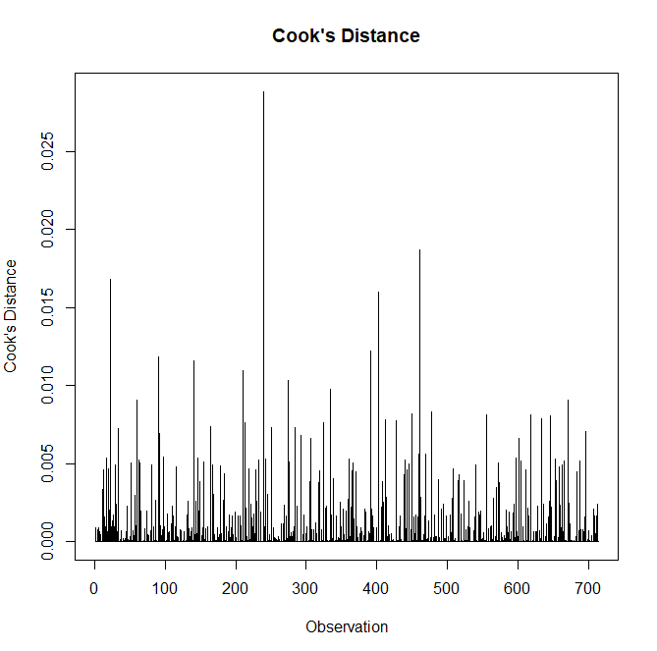
Figure: Cook's Distance for the Logistic Regression Model.

11. Model Strengths and Potential Improvements

Strengths
- Logistic regression is appropriate for the binary survival outcome.
- The dataset provides multiple meaningful predictors.
- The train-test split provides an independent basis for evaluating predictions.
- Hypothesis testing provides evidence about important relationships.
- Model diagnostics help identify potentially influential observations.

Potential Improvements
- Test additional relevant predictors.
- Investigate interaction effects.
- Compare alternative classification algorithms.
- Use repeated cross-validation for more robust performance estimation.
- Perform feature engineering where appropriate.
- Compare logistic regression with tree-based classification models.

12. Conclusion
The analysis applied statistical techniques and predictive modeling methods in R to investigate passenger survival. Descriptive statistics and correlation analysis were used to understand the dataset, while a Chi-square test provided strong evidence of an association between passenger class and survival status.
A logistic regression model was developed using passenger class, sex, age, and fare as predictors. The dataset was divided into training and testing subsets, and the trained model was used to generate survival predictions. Model performance was evaluated using classification metrics and ROC analysis, while Cook's Distance was used as a diagnostic measure to identify potentially influential observations.
Overall, the analysis demonstrates how statistical testing, classification modeling, performance evaluation, and diagnostic analysis can be combined into a structured predictive modeling workflow using R.

